**The Fundamental Unit of Life**

# History of Cell

* The **cell** is the basic structural and functional unit of all living organisms. It is the smallest part of the body of an organism which is capable of independent existence and is able to perform all the essential functions of life.
* The history of cell science began in **1665**, with the observation of a thin section of bottle cork by the English scientist **Robert Hooke**.
* In **1838**, **Matthias Schleiden** and **Theodor Schwann** proposed a basic cell theory. In 1858, another scientist, Virchow, made an addition to the existing cell theory.
* The **postulates of the modern cell theory** are
  + The cell is the smallest unit of structure of all living things.
  + The cell is the unit of function of all living things.
  + All cells arise from pre-existing cells.
* Cells vary in **number**. Examples: Single-celled *Amoeba,* few-celled *Spirogyra* and multi-celled human being. They vary in **size**. Examples: Bacteria are the smallest, nerve cells are the longest and the ostrich egg is the largest. They vary in **shape**. Example: Columnar epithelial cells.

# Types of Organisms

|  |  |
| --- | --- |
| **UNICELLULAR ORGANISMS** | **MULTICELLULAR ORGANISMS** |
| 1. Made of one cell. | 1. Made of many cells. |
| 2. There is no division of labour. | 2. Cells are specialized to perform  specific functions. |
| 3. A single cell participates in  reproduction. | 3. Only some cells (germ cells)  participate in reproduction. |
| 4. Lifespan is short. | 4. Lifespan is long. |
| 5. Examples: *Amoeba*, *Paramecium* | 5. Examples: Fungi, plants, animals |

**Differences between Prokaryotic and Eukaryotic Cells**

|  |  |
| --- | --- |
| **PROKARYOTIC CELL** | **EUKARYOTIC CELL** |
| 1. Absence of a well-defined nucleus. | 1. Presence of a well-defined nucleus with  a nuclear membrane. |
| 2. Nucleolus is absent. | 2. Nucleolus is present. |
| 3. Presence of a single length of only  DNA. | 3. Presence of several lengths of DNA,  wound around certain proteins. |
| 4. Presence of smaller ribosomes. | 4. Presence of larger ribosomes. |
| 5. Examples: Bacteria, blue-green algae | 5. Examples: *Amoeba*, plants, animals |

**Structural Organization of a Cell**

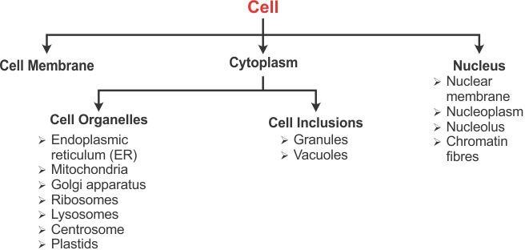

|  |  |
| --- | --- |
| **CHARACTERISTICS** | **FUNCTIONS** |
| **Plasma membrane** | |
| Very thin, flexible and delicate living semi- permeable membrane | Acts as an effective barrier and regulates the entry of certain solutes and ions |
| **Cell wall** | |
| Freely permeable, mainly composed of cellulose | Gives rigidity and shape to the plant cells and provides protection |
| **Cytoplasm** | |
| Contains a mixture of water and soluble organic and inorganic compounds and various cell organelles | Seat of occurrence of glycolysis (production of pyruvic acid) |
| **Endoplasmic reticulum** | |
| May be smooth (SER) or rough (RER) | Acts as a supportive framework of the cell |
| **Mitochondria** | |
| Double-walled, inner wall thrown into folds called cristae | Seat of aerobic respiration and synthesises respiratory enzymes and energy-rich compounds |
| **Golgi apparatus (in animal cells)**  **Dictyosomes (in plant cells)** | |
| Consists of a set of membrane-bounded, fluid-filled vesicles and vacuoles | Synthesis of the plasma membrane, cell wall etc. and synthesis and secretion of enzymes and hormones |
| **Ribosomes** | |
| Single-walled, dense, spherical bodies composed mainly of RNA and proteins | Synthesis of proteins |
| **Lysosomes** | |
| Contains 40 different types of enzymes | Intracellular digestion |

|  |  |
| --- | --- |
| **CHARACTERISTICS** | **FUNCTIONS** |
| **Centrosomes** | |
| Contains one or two centrioles which are surrounded by radiating microtubules to form  an aster shape | Initiates and regulates cell division |
| **Plastids** | |
| Double membrane, proteinaceous matrix containing DNA and disc-like structures  called thylakoids containing chlorophyll | Chromoplasts: Impart colour to flowers and fruits Chloroplasts: Trap solar energy for photosynthesis  Leucoplasts: Store starch |
| **Nucleus** | |
| Mostly spherical and dense, surrounded by nuclear membrane with pores | Regulates cell cycle and cell functions |
| **Nucleolus** | |
| Round, one or more in number | Participates in protein synthesis by forming and storing RNA |
| **Chromatin fibers** | |
| Network of thread-like structures which are made of DNA | Chromosomes carry hereditary information or genes |
| **Vacuoles** | |
| Non-living structures | Storage of water and other substances, food, pigments and waste products |
| **Granules** | |
| Small particles, crystals or droplets | Starch (in plant cells), glycogen (in animal cells) and fat-containing granules serve as food for the cell |

**Differences between Plant and Animal Cells**

|  |  |
| --- | --- |
| **PLANT CELL** | **ANIMAL CELL** |
| 1. Presence of a definite cell wall made of  cellulose | 1. Absence of a cell wall |
| 2. Cell membrane present internal to the  cell wall | 2. Cell membrane forms the boundary of  the cell |
| 3. Absence of centrosome | 3. Presence of centrosome |
| 4. Absence of centriole | 4. Presence of centriole |
| 5. Presence of plastids | 5. Absence of plastids |

**Transport of Materials across Cells**

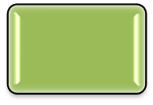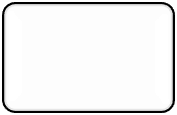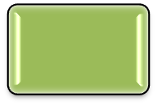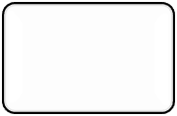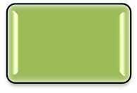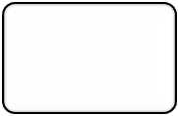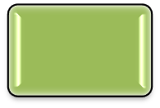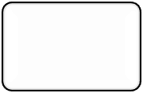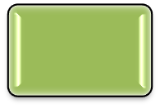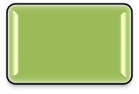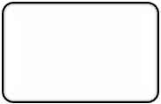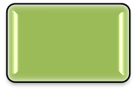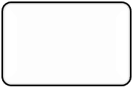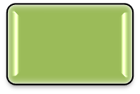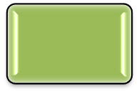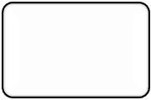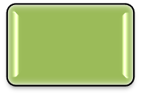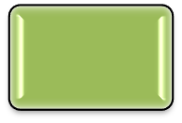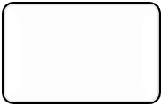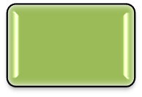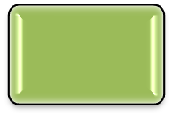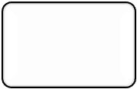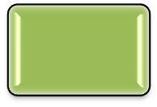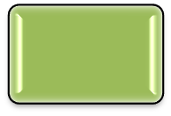

Transport of

materials across cells

Passive

transport

Active

transport

Bulk transport

Simple

diffusion

Facilitated

diffusion

Osmosis

Pinocytosis

Endocytosis

Exocytosis

Endosmosis

Exosmosis

Phagocytosis

Potocytosis

Receptor-

mediated endocytosis

* **Passive transport** is a kind of diffusion in which an ion or a molecule crossing the cell membrane moves against its electrochemical or concentration gradient.
* In **simple diffusion**, molecules of gases such as oxygen and carbon dioxide enter the cell without the help of transport proteins such as permeases.
* In **facilitated diffusion**, ions or molecules cross the membrane rapidly by using specific proteins called transport proteins or permeases which are present in the membrane.
* The spontaneous passage of water molecules from a region of high-water concentration to a region of low water concentration through a selectively permeable membrane is called **osmosis**.
* The process by which water molecules enter a cell is called **endosmosis**.
* The process by which water molecules move out of the cell is called **exosmosis**.
* In plant cells, when excess of exosmosis occurs, the cytoplasm and plasma membrane shrink away from the cell wall. This is known as **plasmolysis**.
* **Active transport** is the movement or transport of substances through a biological membrane such as the cell membrane. This process requires energy.
* Large molecules are continuously imported or exported into the cells across the plasma membrane. The process where the cells either release or absorb fluids and particles through their outer membrane is called **bulk transport**.
* Materials enter a cell by invagination and formation of vesicles. As the materials leave the cell, the membrane of a vesicle fuses with the plasma membrane and extrudes its contents to the surrounding medium. This outward transport of materials by using carrier molecules is called **exocytosis**.
* **Endocytosis** is the intake or ingestion of materials by cells through the plasma membrane.
* **Phagocytosis**, also known as **cell eating**, is a common method in which substances are taken up in the solid form.
* In **potocytosis**, small molecules or ions are specifically internalized into the cell.
* **Receptor-mediated endocytosis** is a pathway for selective uptake of large molecules such as ligands in clathrin-coated pits.
* In **pinocytosis**, also known as **cell drinking**, substances are taken up by the cell in the fluid form.